Presented by: *Grant, Gabe, Adrian, Jordan*

Harrisburg University

The Walking Dead: Pseudo-Salvation

Project Proposal

A survival horror digital game for the hit series the walking dead

Version 1.0

December 15, 2016

Contents

Company Overview 2

Project Overview 2

Project Goal 2

Project description 2

Scope of work 2

Design Specifications 3

Team structure 4

Expertise Summary 4

Tasks 5

Implementation Plan 5

Financial Metrics 6

Risks and issues Management 6

Potential exceptions and problems 6

Timeline 6

Similar game content 7

# 

# Company Overview

A team consisting of Grant Hoover, Gabe Hicks, Adrian Jones and Jordan Davenport will be responsible for developing the Walking Dead game specified in this proposal document. The four are a set of Harrisburg University students devoted to creating unique, fun games; together, they encompass all skills required to complete the proposed game. They look forward to making this the best Walking Dead game possible.

Each of the four have had extensive experience with creating new media and interactive media content, including expansive projects for external clients, as well as game development experience. Previous development history includes independent games, game jams, mobile apps, and more. Between the team, experience with industry-leading software is covered, including Unity, Game Maker, Adobe, Autodesk, Trello, and more. The team performs best in an Agile development processes, focusing on creating iterative deliverables as often as possible to assure an optimal final product. The four prefer a flat management style, each on an equal decision-making level.

# Project Overview

The Walking Dead: Pseudo-Salvation is a survival horror video game. It follows the player- Mr. Merle Dixon- as he travels across post-pandemic South East USA with a set of companions in an effort to reach a supposed safe haven in Kings Bay Georgia. As the player travels across miles of apocalyptic greenlands, they must wrestle with the constant onslaught of walkers, handle emergency situations, collect and preserve resources, make numerous difficult decisions, and keep up relations with their companions in an effort to reach the safe haven in one piece.

The game will have similar mechanics and play style to the popular indie game Don’t Starve, while adding graphics and style from the Walking Dead IP, as well as an engaging storyline and interpersonal mechanic system.

# Project Goal

The goal of this project is to create an acclaimed addition to the Walking Dead IP, capturing new interest in the series while strengthening current viewer engagement. The target review average is 70%+ and the target ESRB rating it T. The game will appeal primarily to males year 12 and up.

The game will focus on extensive replayability through procedural environments and situations, as well as numerous forms of meaningful player choice. While the game is not planned to expand upon the Walking Dead story line greatly, it will focus on interest in regards to the IP.

# Project description

The game will be a mission-based exploratory game with a look and feel revolving around The Walking Dead. The scope of work and design specifications are as follows:

## Scope of work

* 2 complete missions
  + Each mission averaging 10 minutes long
* Each mission based upon procedurally-generated content
  + Landscape
  + Walkers
  + Resources
  + 5 types of roadblocks
  + 5 types of disasters
* Various types of resources to manage
  + 5 kinds of weapons, both close combat and projectile-based
  + Ammunition
  + Transportation vehicles
  + Life-dependent resources
    - Will die if not managed correctly
    - Water
    - Food
    - May need to help companions with these resources
* Fluid, intense fighting system
  + Ability to fight both other humans as well as walkers
  + AI for enemy’s attacks
  + Special Walker killing
    - Must headshot to kill, other attacks only dismember
* Karma system
  + Ability for players to make ethical decisions, resulting in Karma score
  + Different Karma scores affect difficulty, other NPC decisions
* Choice making system
  + Certain roadblocks and disasters require players to make choices
  + Different choices produce different results later in the game
  + May affect Karma, dependent on the choice
* Plot and Story
  + Overarching story line with basic plot
  + Dialogue between characters
  + Choices affect end result in story
* Environment
  + Expansive graphic assets, including
    - NPCs
    - Resources
    - Land
    - Character
* Inventory System for keeping track of and using items
* Crafting System
  + Allows player to produce combinations of objects that form a larger whole
  + Each item produced offers specific properties
* Day/Night System
  + Gradual change in day cycle
  + Different time periods produce different enemies and incidents
* Map for player location tracking

## Design Specifications

* ¾ view shooter
* Open-world format
* Tense, dreary mood
  + Broken-down objects, lack of actual life
* Assets strongly tied to Walking Dead IP assets
* Technology to be used
  + *Unity:* Main game engine
  + *Adobe Photoshop/Illustrator*: Sprite creation tools
  + *Autodesk Maya*: Modelling tool
  + *Adobe Premiere/After Effects*: Video editing software
  + *Main platform*: PC, Xbox One, PS4
  + *Trello*: Management tool

# Team structure

The team structure for this project will consist of the following:

**Internal**- Grant, Adrian, Jordan and Gabe as the main project team members. The four will be responsible for developing and/or gathering all assets to be used within the game, including but not limited to art, written content, and code.

**Client**- The client will be John Williamson, the point of contact for high-level issue and questions.

**External**- John Williamson will also be used as a reference for technical-related advice and assistance.

**Outsourcing**- There are currently no plans for outsourcing work to personnel outside the internal structure, however content already developed within the Walking Dead IP, including audio, graphic and written content, will be used when deemed necessary or beneficial by the internal team.

## Expertise Summary

Below is a detailed list of experience and skillsets possessed by each of the internal team members, related to game development:

* **Grant**- Programmer and Designer
  + **Software Experience**- Autodesk 3DS Max, Autodesk Maya, Autodesk MudBox, Adboe Photoshop, Adobe Illustrator, Adobe Premiere Pro, Adobe After Effects, Unity, GameMaker, Unreal Engine, CryEngine, Adobe Flash Professional, GameSalad, Microsoft Office, Trello, Sharepoint
  + **Language Experience**- C++, C, C#, Java, JavaScript, VBA, Processing
  + **Skillset-** Grant has experience creating numerous games in game jams, game development camps, class assignments and personal work. He focuses on programming and design, but can assist with art and other assets when necessary.
* **Gabe**- Artist
  + **Software Experience**- Audacity, Autodesk 3DS Max, Autodesk Maya, Autodesk MudBox, Adboe Photoshop, Adobe Illustrator, Adobe Premiere Pro, Adobe After Effects, Unity, GameMaker, Unreal Engine, CryEngine, Adobe Flash Professional, GameSalad, Microsoft Office, Trello, Sharepoint
  + **Skillset** – Gabe has experience, like grant, in multiple game jams and experience in working in a marketing field of the game design.
* **Jordan**- Artist
  + **Software Experience**- Audacity, Autodesk 3DS Max, Autodesk Maya, Autodesk MudBox, Adboe Photoshop, Adobe Illustrator, Adobe Premiere Pro, Adobe After Effects, Unity, GameMaker, Unreal Engine, CryEngine, Adobe Flash Professional, GameSalad, Microsoft Office, Trello, Sharepoint
  + **Skillset** – Jordan has experience creating graphical content, as well as marketing and experience with customers
* **Adrian-** Programmer
  + **Software Experience** – Visual Studios, Web Matrix, Atom, Brackets, Eclipse, Mono Develop, Slack, Github, Unity, Game Maker, Game Salad, Mono Game
  + **Language Experience** – C#, C++, C, Java, Javascript, PHP, SQL, Objective C, Python, Game Maker Language
  + **Skillset** – Adrian has experience in creating games through Global Game Jams, class assignments, personal work, and contracting work. He is best suit to design and programming.

# 

# Tasks

At this point in time, the tasks associated with completing this project are in a high-level state. As development begins, the task backlog will be broken down and further specified. The following is the current set of tasks to be completed:

* Creation of art assets
* Creation of audio assets
* Development of player movement system
* Development of combat system
* Development of enemy AI system
* Development of 2 missions
* Writing of overall storyline
* Development of karma system
* Development of choice making system
* Development of inventory system
* Development of resource management system
* Development of crafting system
* Creation of resources
* Creation of roadblocks and disasters
* Creation of map
* Development of day/night system

# Implementation Plan

The development process will involve the creation of an Alpha, Beta and Release build. The Alpha build will contain only the most basic aspects of the game to be playable- features include movement and basic resource and interactions systems. After the Alpha build, a Beta build will be produced, containing mostly completed basic game elements, as well as at least a playable version of all other aspects and systems of the game. While the first two releases will be internal-only for review, the last build will contain all finished content for the game and will be a public release. At the point of public release, the game will be released to all development platforms.

# Financial Metrics

The game will require extensive time-based resources from the internal development team. The game will not require any advances or other expenses, and all software used will be paid for by either Harrisburg University of the internal team members. There will be no fees, and no costs will be associated will additional productions items not covered in this proposal. This game will be at no financial cost to the client.

# Risks and issues Management

## Potential exceptions and problems

* Reduction of scope: As with any creative project, there is always a possibility of the inability to complete all content for the game within the specified time constraints. If this scenario were to arise, the team has assembled an internal list of core features to keep, as well as expendable features that could be thrown out if required due to time restraints.
* Issues with procedural generation system: If the procedural generation system is not in a basic, functional state by the Alpha build, the team is prepared to move to a static environment system. It was decided that the game would be better completed without it than not completed at all.

# Timeline

The development process will involve the creation of an Alpha, Beta and Release build. Development resources will be split amongst the four internal members of the team, dependent of availability and skillset. The timeline for the development of the proposed game is as follows:

* February 15th - Presentation of this proposal document
* Week of February 15th - Development of Alpha build
  + Creation of main art assets
    - Character
    - Basic resources
    - Basic landscape
  + Movement completed
  + Basic combat system implemented
  + Basic AI enemy system implemented
  + Halfway through development of first mission and overall storyline
  + Prototype Karma system
  + Prototype choice making system
  + Prototype inventory system
  + Prototype resource management system
  + Prototype crafting system
* February 22nd – Presentation of Alpha build
* Week of February 22nd – Development of Beta build
  + Completion of main art assets, development of remaining assets
  + Development of audio assets
  + Combat system completed
  + Enemy AI system completed
  + Completion of overall storyline and missions
  + Continuation of Karma system
  + Continuation of choice making system
  + Completed inventory system
  + Completed resource management system
  + Continuation of crafting system
  + Development of disasters and roadblocks
  + Creation of map
  + Development of day/night system
* February 29th – Presentation of Beta build
* Week of February 29th – Development of main build
  + Completion of all remaining items
  + Extensive quality testing
* March 7th – Presentation of Release build

# Similar game content

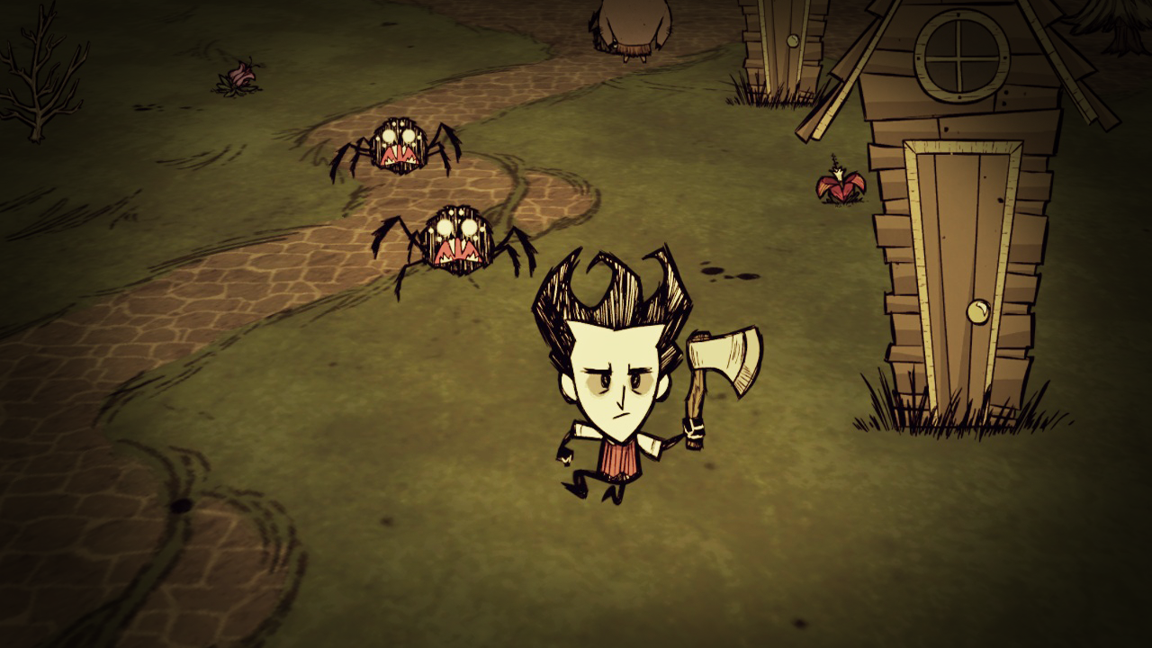

The game will utilize an art and movement style similar to above